Copyright ©2021-2099 wuxinmiaoi. All rights reserved

**实验要求：**

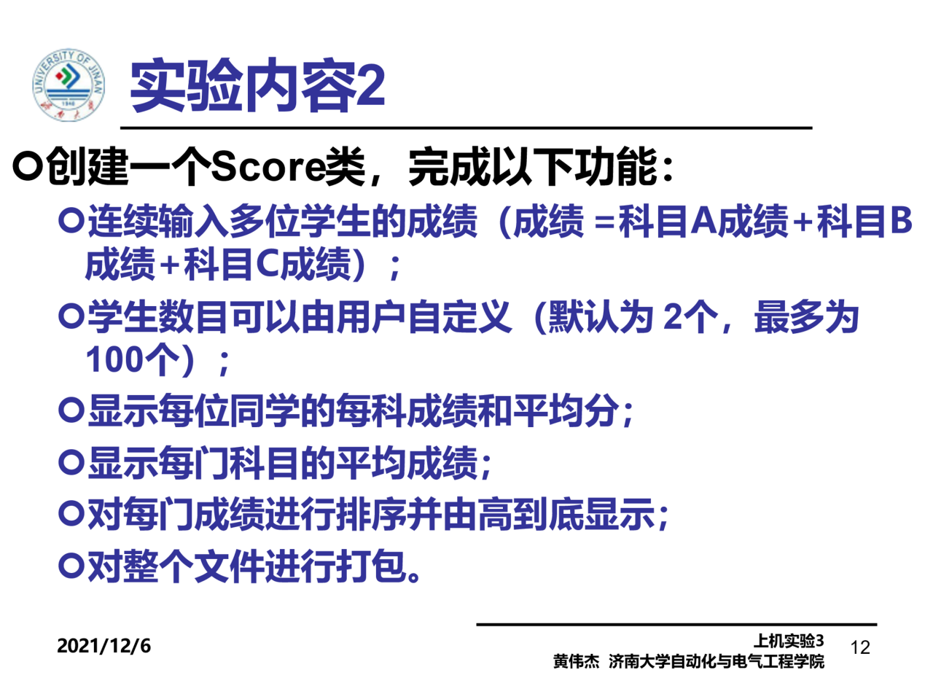

**实验程序**

#include <iostream>

#include <string>

using namespace std;

class score

{

public:

score()

{

time = 2;//默认为2

cout << "无参数解析函数的调用" << endl;

}

score(int time1)

{

time = time1;

cout << "用户自定义解析函数的调用" << endl;

}

~score()

{

cout << "析构函数的调用" << endl;

}

void input()

{

for (int i = 0; i < time; ++i)

{

cout << "请输入学生的姓名和三科的成绩" << endl;

cin >> name[i];

cin >> cj[i][1] >> cj[i][2] >> cj[i][3];

}

}

void show()

{

for (int i = 0; i < time; ++i)

{

cout << name[i] << "学科A的成绩为：" << cj[i][1] << " ";

cout << name[i] << "学科B的成绩为：" << cj[i][2] << " ";

cout << name[i] << "学科C的成绩为：" << cj[i][3] << endl;

}

}

void avg()

{

double a = 0;

for (int i = 0; i < time; ++i)

{

a = cj[i][1] + cj[i][2] + cj[i][3];

cout << name[i] << "平均成绩为" << a / 3 << " ";

}

cout << endl;

}

void showavg()

{

double a = 0;

double b = 0;

double c = 0;

for (int i = 0; i < time; ++i)

a = a + cj[i][1];

for (int i = 0; i < time; ++i)

b = b + cj[i][2];

for (int i = 0; i < time; ++i)

c = c + cj[i][3];

cout << "学科A的平均成绩为" << a / time << " ";

cout << "学科B的平均成绩为" << b / time << " ";

cout << "学科C的平均成绩为" << c / time << endl;

}

void px()

{

for (int i = 0; i < time; ++i) //将name【】数组复制一个

copy[i] = name[i];

for (int i = 0; i < time - 1; i++)

for (int j = 0; j < time - i - 1; j++)

if (cj[j][1] < cj[j + 1][1]) //改变了name【】数组数据的位置

{

double temp = cj[j + 1][1];

cj[j + 1][1] = cj[j][1];

cj[j][1] = temp;

string t = name[j + 1];

name[j + 1] = name[j];

name[j] = t;

}

cout << "学科A的排序为" << endl;

for (int i = 0; i < time; ++i)

{

cout << name[i] << " " << cj[i][1] << endl;

}

for (int i = 0; i < time; ++i) //重置name【】数组

name[i] = copy[i];

for (int i = 0; i < time - 1; i++)

for (int j = 0; j < time - i - 1; j++)

if (cj[j][2] < cj[j + 1][2])

{

double temp = cj[j + 1][2];

cj[j + 1][2] = cj[j][2];

cj[j][2] = temp;

string t = name[j + 1];

name[j + 1] = name[j];

name[j] = t;

}

cout << "学科B的排序为" << endl;

for (int i = 0; i < time; ++i)

{

cout << name[i] << " " << cj[i][2] << endl;

}

for (int i = 0; i < time; ++i) //重置name【】数组

name[i] = copy[i];

for (int i = 0; i < time - 1; i++)

for (int j = 0; j < time - i - 1; j++)

if (cj[j][3] < cj[j + 1][3])

{

double temp = cj[j + 1][3];

cj[j + 1][3] = cj[j][3];

cj[j][3] = temp;

string t = name[j + 1];

name[j + 1] = name[j];

name[j] = t;

}

cout << "学科C的排序为" << endl;

for (int i = 0; i < time; ++i)

{

cout << name[i] << " " << cj[i][3] << endl;

}

}

private:

int time;

double cj[100][100];

string name[100];

string copy[100];

};

int main()

{

score a(3);

a.input();

a.show();

a.avg();

a.showavg();

a.px();

return 0;

}

**实验程序输出结果：**

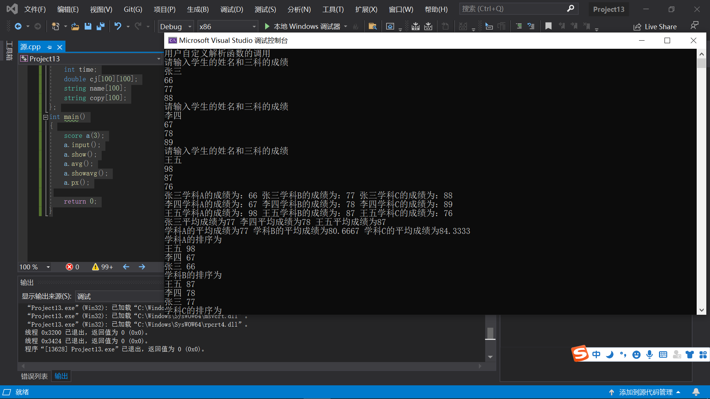

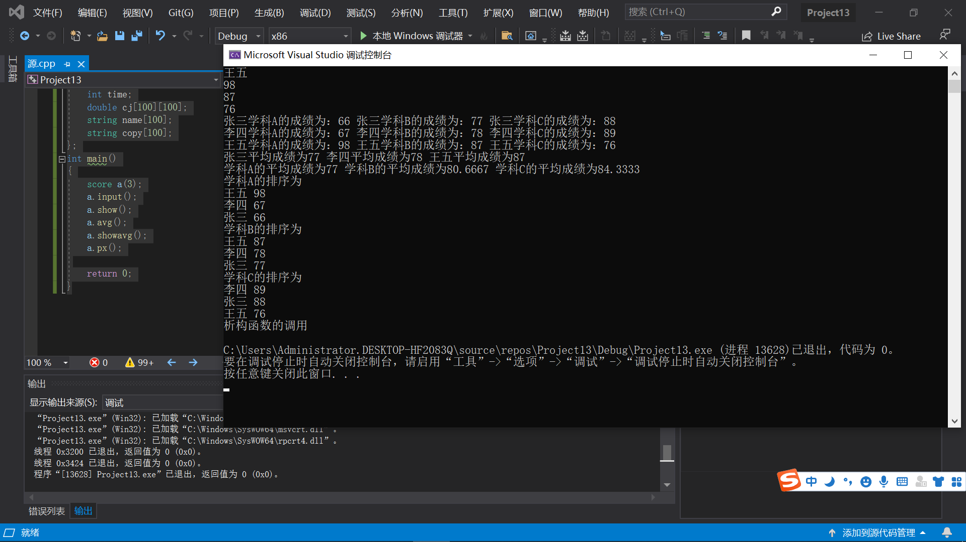

**实验总结：**

刚开始编译一直错误，排序结果不正确，经查询资料后得到错误原因：调用对象时没有传递其地址，故在子函数里进行的修改不会影响别的地方。

理解了类和对象的概念，掌握声明类和定义对象的方法，初步掌握了使用类和对象编制C++程序，也懂得了类和象的概念，更深层次的学习了相关知识。